VMs - Requirements and Recommendations

You can use your existing computer if it meets the minimum requirements:

* A computer must have a compatible x86-64 CPU.
* A CPU (central processor unit) with 4 cores or more that is compatible with ESXi 7.0.
* 32 GB of RAM. If you have a laptop with 16 GB of RAM, your VMware will be too slow and it will be a challenge to run a nested VM on a virtual ESXi host (that is running as a VMware Workstation VM).
* 100 GB of free disk space. It is recommended that you use SSD. If you don’t have SSD, use high-performance hard disk drives (HDD).

Configuration of Our vSphere 7

Let’s look at the configuration used in the vSphere 7. We’ll be using VMware Workstation 15/16 installed on a Windows 10 machine.

Then we will create **two** virtual machines on VMware Workstation and install ESXi 7 on these two VMs.

VMware **vCenter 7** is installed as a **vCenter Server Appliance (VCSA)** on a nested VM residing in the first ESXi host.

**Virtual network adapters** of VMware Workstation VMs are connected in the **bridged mode** to the **same physical network** that is connected to the host (physical machine) on which VMware Workstation is installed (*192.168.11.0/24*).

Nested VMs created on ESXi VMs are connected to the same network (*192.168.11.0/24*).

This configuration is simple, and later you can create more complex configuration, add more virtual network adapters to ESXi VMs and create separate VM networks, vMotion networks, and so on.

The advantage of using the bridged network connection for VMware Workstation VMs for a vSphere 7 is that you can use two laptops or desktop computers, install VMware Workstation on them, deploy one ESXi VM on each physical machine and connect all machines to the same network. Virtual machines running on different physical machines can communicate with each other over the network in this case. A physical machine, virtual machines (ESXi) and nested VMs are connected to the gateway (*192.168.11.2*) and can access external networks and the internet. ***VMnet0***is the standard name of the bridged network in VMware Workstation. Use a virtual network editor to create and edit networks in VMware Workstation.

IP addresses used in our vSphere 7

The address of the physical network: *192.168.11.0/24*

The IP address of the physical router/DNS server/DHCP server: *192.168.11.2*

The IP address of the physical machine on which VMware Workstation 15 is installed: *192.168.11.101*

**ESXi01**

VM name: *ESXi+vC*

Hostname: *ESXi-30*

IP address: *192.168.11.30*

**ESXi02**

VM name: *ESXi-27*

Hostname: *ESXi-27*

IP address: *192.168.11.27*

**vCenter** (a nested VM)

VM name: *vCenter7*

Hostname: *vCenter7*

IP address: *192.168.11.31*

The components of our vSphere 7 are shown on the diagram below.

[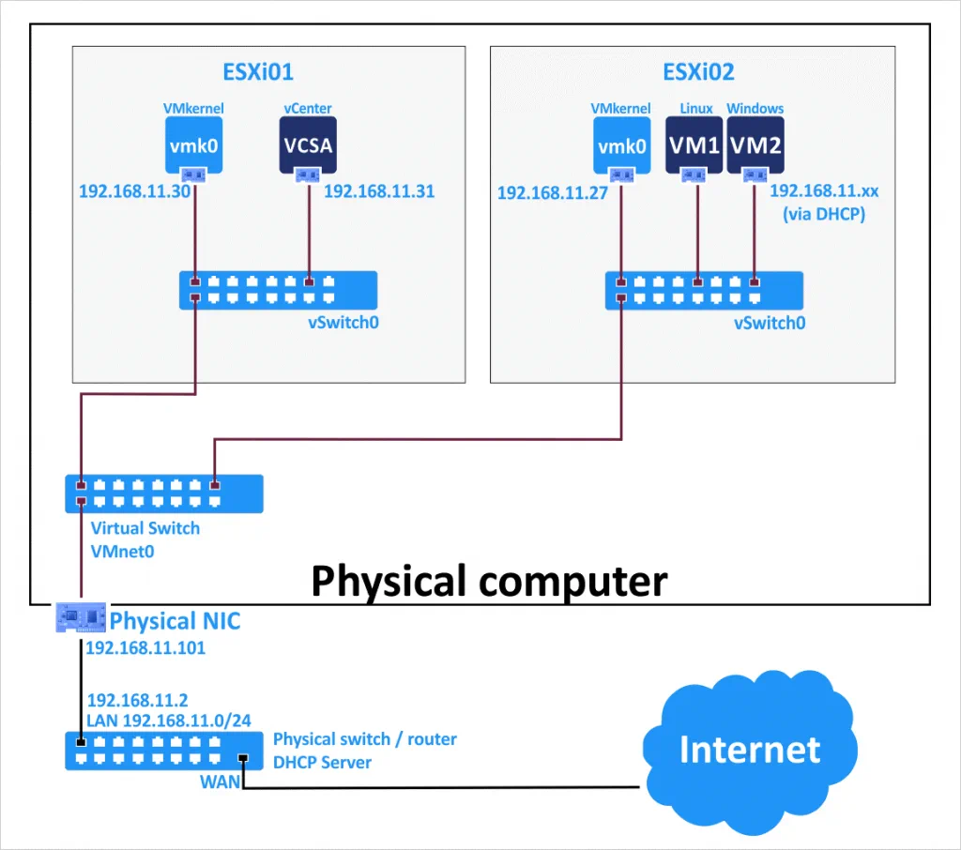](https://www.nakivo.com/blog/wp-content/uploads/2020/08/vSphere-7-home-lab-diagram.png)

Creating the First VM

Now we let’s go to the practical part and create a virtual machine on VMware Workstation for installing ESXi 7 on this VM.

Open VMware Workstation, click **File > New Virtual Machine** (Ctrl+N).

[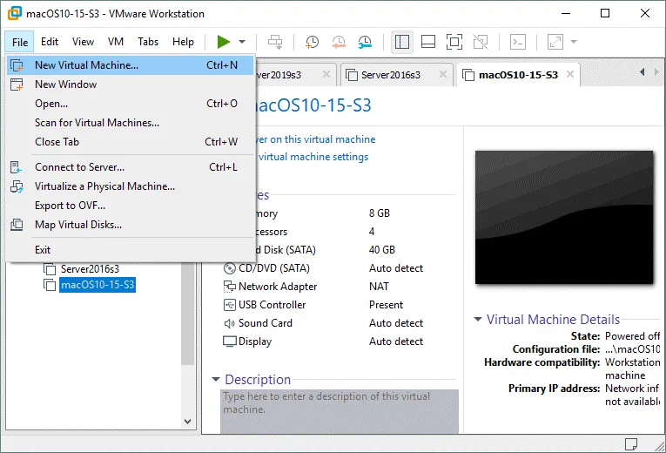](https://www.nakivo.com/blog/wp-content/uploads/2020/08/Creating-a-new-VM-to-install-ESXi-for-a-vSphere-7-home-lab.png)

A new virtual machine wizard opens.

**What type of configuration do you want?** Select **Custom**. Click **Next** at each step of the wizard to continue.

**Choose the Virtual Machine Hardware Compatibility.** Select the newest hardware compatibility version if you are not planning to migrate a VM and run the VM on a host with an older VMware Workstation version.

[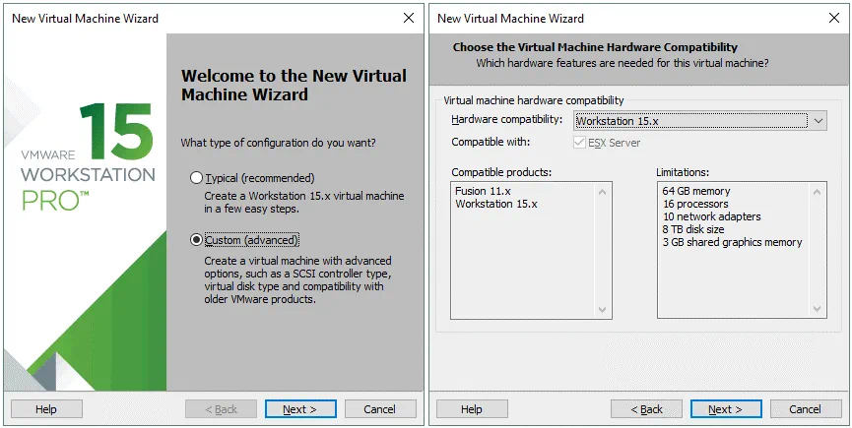](https://www.nakivo.com/blog/wp-content/uploads/2020/08/Building-a-VMware-vSphere-7-home-lab-%E2%80%93-creating-a-new-VM.png)

**Guest Operating System Installation.** Select **Installer disc image file (iso)** and define the path to the ESXi 7 ISO installation image. You can download the ESXi 7 ISO installation image from the VMware website.

**Name the Virtual Machine.** Enter the virtual machine name, for example, *ESXi+vC*. Set the location on your disk to store VM files. We select *H:\VMs-blog\ESXi+vC* to store the VM files.

[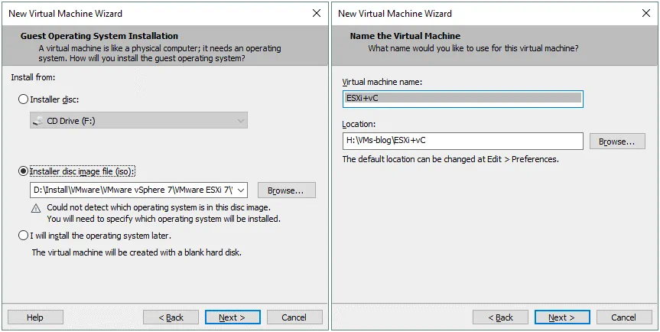](https://www.nakivo.com/blog/wp-content/uploads/2020/08/Selecting-the-ESXi-ISO-image-to-install-ESXi-7-for-the-ESXi-7-home-lab.png)

**Processor Configuration.** Specify 4 or more processors for this virtual machine.

**Memory for the Virtual Machine.** Select 16 GB of memory or more for this virtual machine because later a nested vCenter VM should be deployed on this ESXi VM.

[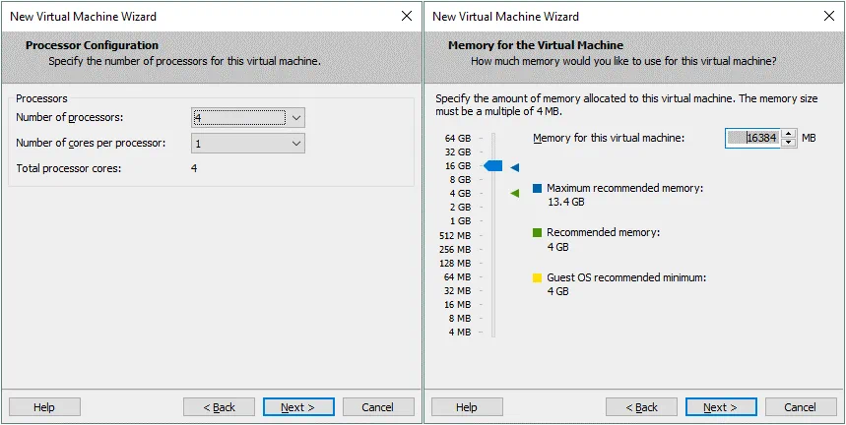](https://www.nakivo.com/blog/wp-content/uploads/2020/08/Configuring-CPU-and-memory-parameters-for-the-ESXi-VM-used-in-vSphere-home-lab.png)

**Network Type.** Select the first option - **Use bridged networking**.

**Select I/O Controller Types.** Select **Paravirtualized SCSI** for the ESXi VM.

[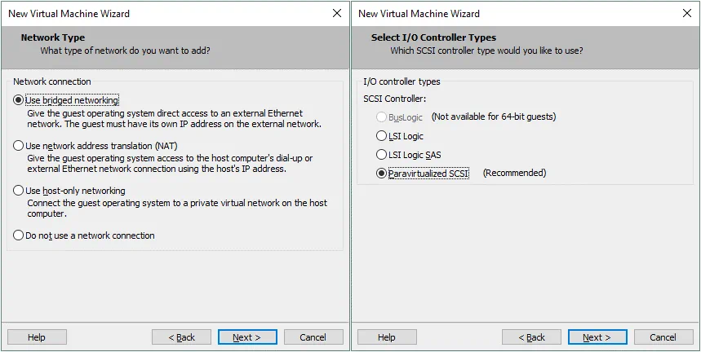](https://www.nakivo.com/blog/wp-content/uploads/2020/08/Building-a-vSphere-7-home-lab-%E2%80%93-configuring-network-settings-for-a-VM.png)

**Select a Disk Type.** Select **SCSI** because it is recommended that you use SCSI disks for ESXi.

**Select a Disk.** Click **Create a new virtual disk** that we will configure in the next steps.

[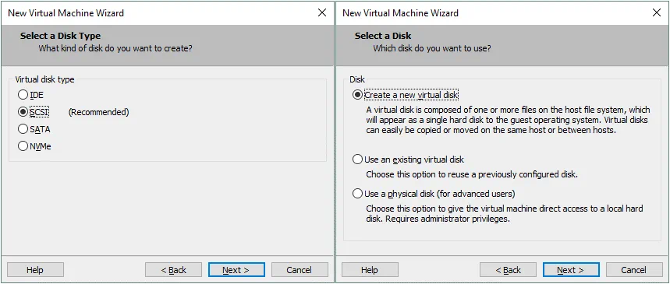](https://www.nakivo.com/blog/wp-content/uploads/2020/08/A-VMware-vSphere-7-home-lab-%E2%80%93-virtual-disk-configuration.png)

**Specify Disk Capacity.** Set the maximum disk size to 20 GB. This virtual disk will be used to install ESXi 7. Later we will create a second larger disk to store files of nested VMs. Select **Store virtual disk as a single file**. Don’t select *Allocate all disk space now*.

**Specify Disk File.** Define a path and a virtual disk file name. We store this virtual disk file as *H:\VMs-blog\ESXi+vC\datastore1.vmdk* in this case. This is the directory where other VM files are stored. It is convenient to store virtual disk files in one directory with other VM files.

[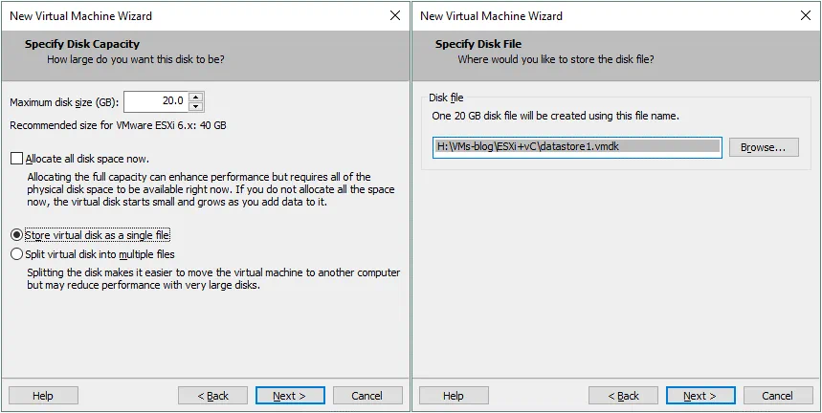](https://www.nakivo.com/blog/wp-content/uploads/2020/08/Virtual-disk-options-for-the-ESXi-VM-used-in-a-vSphere-7-home-lab.png)

**Ready to Create Virtual Machine.** Check the configuration summary for your new virtual machine and if everything is correct, hit **Finish**. We can deselect the **Power on this virtual machine after creation** checkbox because we are going to create the second virtual disk that will be used as a datastore to store files of nested VMs.

[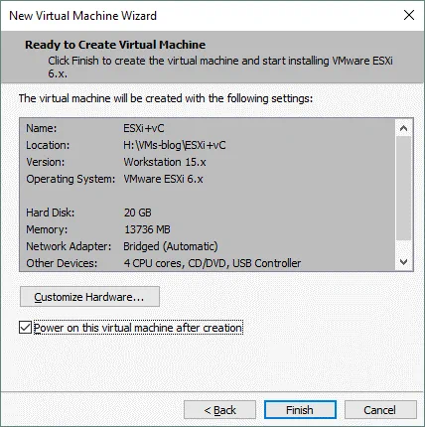](https://www.nakivo.com/blog/wp-content/uploads/2020/08/Ready-to-create-a-virtual-machine-for-a-vSphere-7-home-lab.png)

A virtual machine for installing ESXi 7 is now created. Click **Edit virtual machine settings**.

[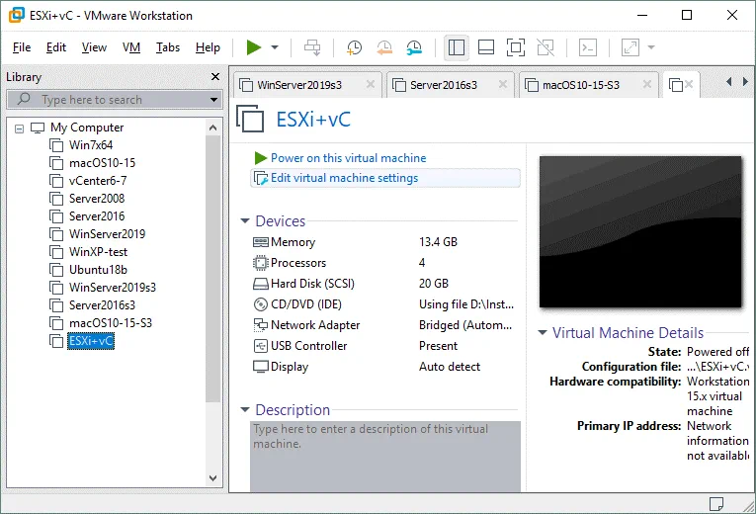](https://www.nakivo.com/blog/wp-content/uploads/2020/08/A-new-VM-for-a-vSphere-7-home-lab-is-created-and-is-ready-to-install-ESXi-7.png)